Easter in Spain

Spain has lots of religious celebrations, but one of the most important is the Easter festival. Each area, city and town has its own way of celebrating, but the town of Seville has some of the most spectacular and elaborate celebrations.

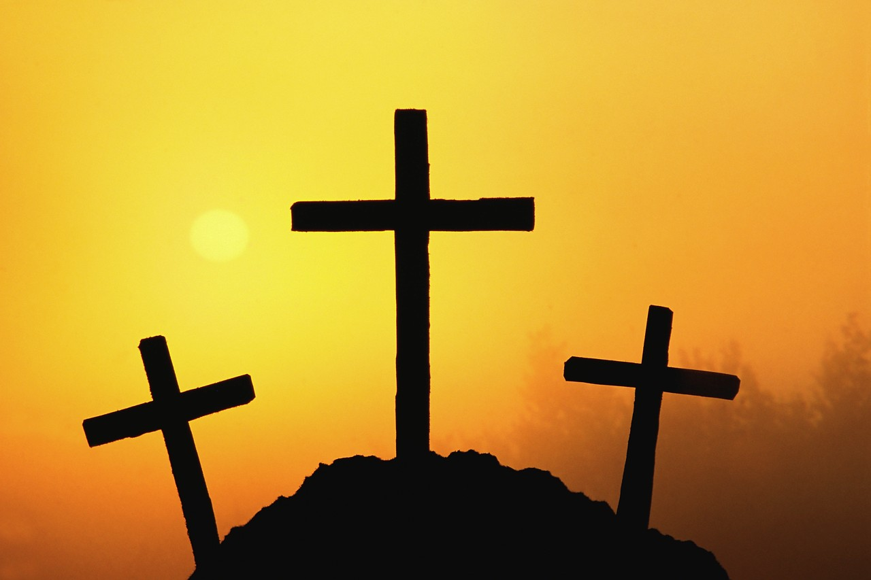

The Easter celebrations get started on Palm Sunday (Domingo de Ramos) in Spain and last all the way through Holy Week – La Semana Santa and finish on Easter Monday – el Lunes de Pascua. Maunday Thursday is called Jueves Santo, Good Friday is called Viernes Santo and Easter Sunday is called Domingo de Resurrectión.
To wish someone a Happy Easter you say
¡Feliz Pascua! or ¡Felices Pascuas!

Palm Sunday

Palm Sunday is called Domingo de Ramos and marks the beginning of Holy Week. Many people go to church for a special mass in the morning and children are often given a palm branch by their godparents. This represents the olive branches laid on the ground to welcome Jesus into Jerusalem.

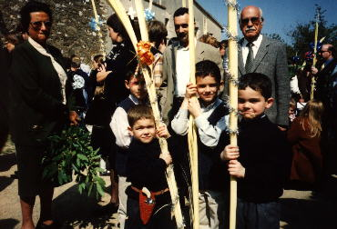

Boys carry a simple palm branch, and the girls carry a branch that has been decorated. They often have sweets, tinsel or other decorations hanging from them.

Holy Week

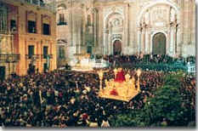

During Holy Week or La Semana Santa lots of street processions take place, sometimes one every day. In Seville the processions set off from all the different churches and go to the cathedral before returning back to their home church. Depending on where the church is this can take hours and may not finish until the early hours of the morning. Lots of people take part in the processions and lots more watch as they pass by.

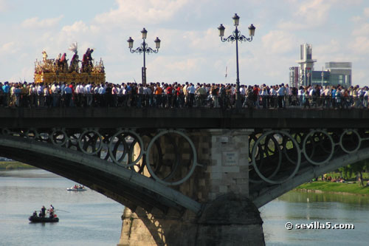

Las procesiones
A big cross, (the Cruz de Guía - Guiding Cross) is carried at the beginning of each procession to mark the way.
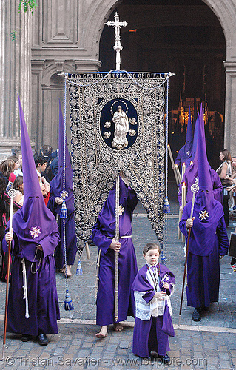

The processions in Holy Week are organised by religious groups called cofradías. The members of these groups are called Nazareños and these are the people you see who are dressed in robes and capes, wearing cone shaped head gear that makes it impossible to know who is behind their disguises.

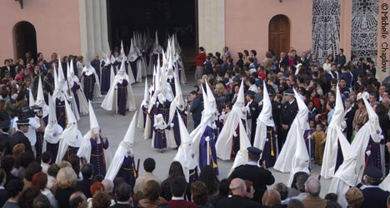

Nazareños

Each religious group has its own costume and these vary in colour from rich satin and brocade to sombre black or blue. They all wear a distinctive pointed hood – this is called a capirote. Sometimes they walk barefoot.

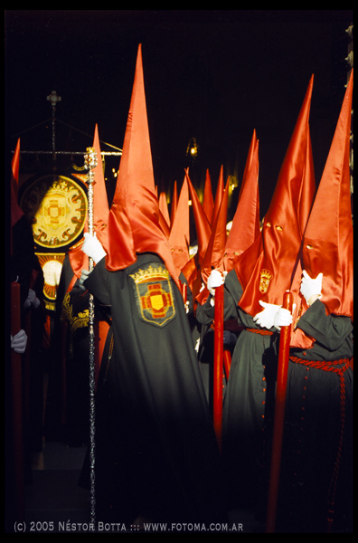
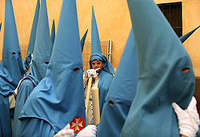
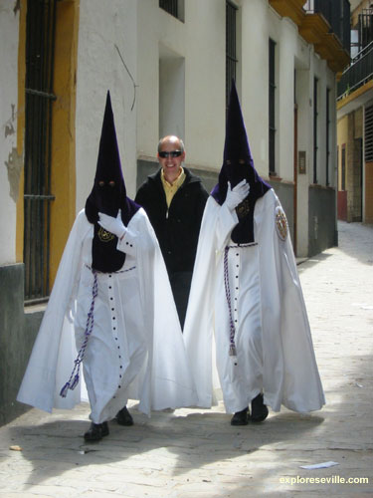

The nazareños usually march in silence in pairs behind banners and they hold long wax candles, which they light when it gets dark.

Los pasos

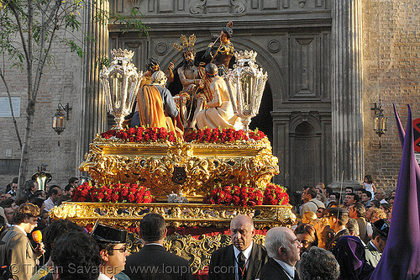
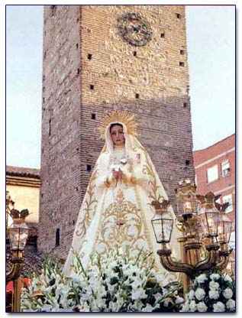
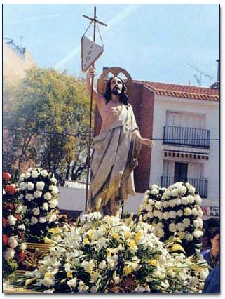
At the centre of each procession are the floats known as pasos.They have religious figures on them – some with Jesus and others with the Blessed Virgin Mary, who is suffering because of Jesus’ death.

The bottom of the paso is richly carved and decorated with fabric, flowers and candles. Many of the floats carrying Jesus are gilded or golden, and those carrying the image of the Virgin Mary are often silver-plated.
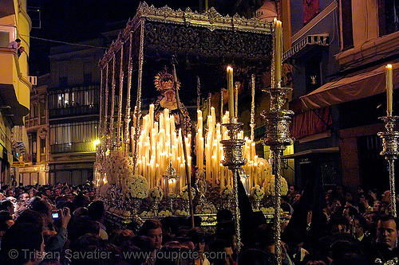
They are often very elaborate and always very heavy – some weigh up to 2000 kilos!

Los costaleros

The pasos are carried by groups of men called costaleros.
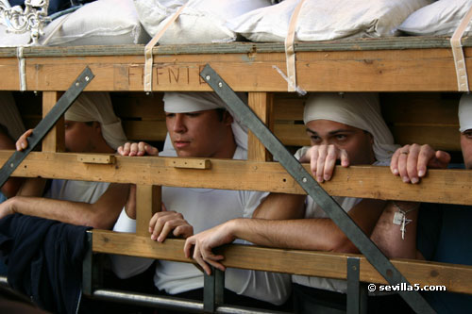
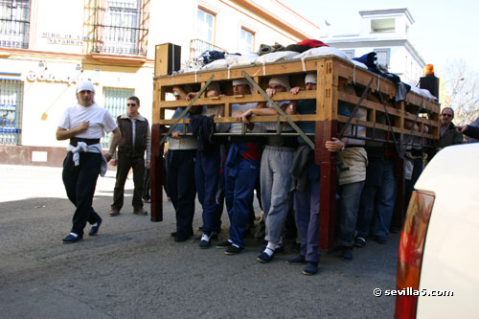

As the floats are so heavy, the men have to practise by carrying sandbags. They protect their heads with special white turbans.

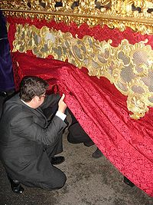

The clothes round the bottom of the float can be quite elaborate and heavily embroidered.

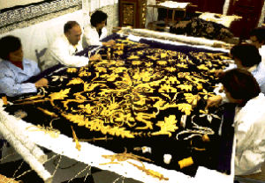

Los penitentes
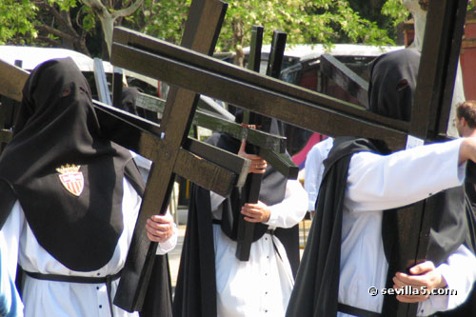
A number of penitentes, carrying wooden crosses, follow each of the floats. They are often carrying out a public penance. There are more of them in the processions on Good Friday than on the other days. They wear a habit and a hood like the nazareños, but the hood is floppy, not pointed.
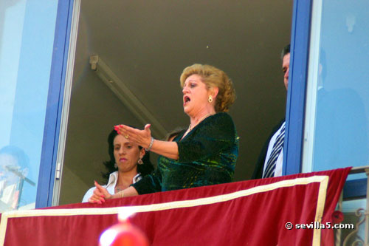
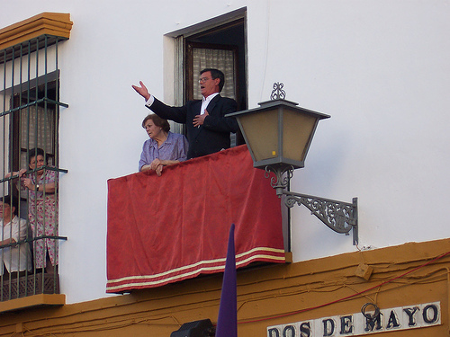

As the processions pass by, sometimes songs are sung by people watching. The songs are called saetas and are sad and mournful.

Easter Sunday
The celebrations are more joyous by the time it gets to Easter Sunday and the mood changes to one of jubilation; emotional reunion ceremonies between the resurrected Jesus Christ and his Mother usually occur during processions held on this day.
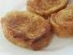
Traditional sweet cakes such as monas, torrijas and pestihos are eaten and the final parades are accompanied by triumphant music. It is a day full of light and colour when church and cathedral bells are heard ringing throughout the country.

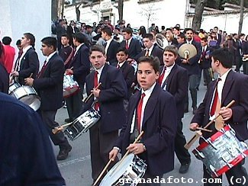

Outdoor festivals, where it is typical to eat chocolate buns or cakes, carry on through Easter Monday and sometimes into Tuesday!

Sweet Treats

Torrijas are typical Spanish cakes that are traditionally made and sold in pastelerías and panaderias at Easter. They are made from bread, milk and honey, fried in olive oil, sweetened with sugar and sprinkled with cinnamon or other dips.
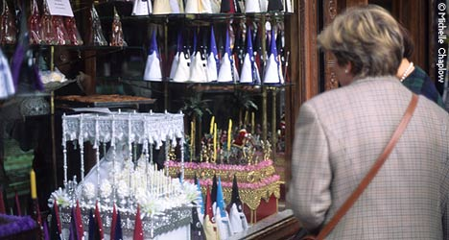
Lollipops and sweets that look like the nazareños are special treats.

